# Department of Computing

**CS-344: Web Engineering**

**Class:** BSCS-5 AB

# Lab 04: Advanced HTML

**Date: March 9, 2017**

**Time: 1000-1300**

# Instructor: Dr. Asad Ali Shah

# Lab Engineer: Qasim Ali Khan

# 

# Lab 04: Advanced HTML

### Introduction:

Students have learned advanced HTML concepts of designing web pages using tables, divisions, and CSS. In this lab, student will practically design a web page using these advanced HTML concepts.

### Lab Objectives:

The objective of this lab is to help students in designing layout of a web page using divisions and CSS. Students will apply different HTML tags and styling concepts they have learned in the lectures to design the layout of a web page.

### Tools:

Dreamweaver, notepad, browser.

### Helping Material:

Lecture slides.

W3Schools: <https://www.w3schools.com/html/default.asp>

Plenty of DIV examples: <http://www.mobilefish.com/tutorials/css/css_quickguide_div_examples_containers.html>

### The float property :

**The float property** specifies whether or not an element should float.

The clear property is used to control the behavior of floating elements.

In its simplest use, the float property can be used to wrap text around images.

The following example specifies that an image should float to the right in a text:

**Example**

**img {**

**float: right;**

**margin: 0 0 10px 10px;**

**}**

**The clear Property**

The clear property is used to control the behavior of floating elements.

Elements after a floating element will flow around it. To avoid this, use the clear property.

The clear property specifies on which sides of an element floating elements are not allowed to float:

**Example**

**div {**

**clear: left;**

**}**

**The clearfix Hack**

If an element is taller than the element containing it, and it is floated, it will overflow outside of its container.

Then we can add overflow: auto; to the containing element to fix this problem:

**Example**

**.clearfix {**

**overflow: auto;**

**}**

**The inline-block Value :**

It has been possible for a long time to create a grid of boxes that fills the browser width and wraps nicely (when the browser is resized), by using the float property.

However, the inline-block value of the display property makes this even easier.

inline-block elements are like inline elements but they can have a width and a height.

**Pseudo-classes**

A pseudo-class is used to define a special state of an element.

For example, it can be used to:

* Style an element when a user mouses over it
* Style visited and unvisited links differently
* Style an element when it gets focus

### Lab Task

### Task 1

BBC is one of the famous public broadcasting company. BBC broadcast news in several ways e.g. television, radio, electronic (via internet) etc. They can be accessed over the internet through their web site: [www.bbc.com](http://www.bbc.com). The layout of this website can be designed using divisions (DIVs). A screenshot of the website is shown below:

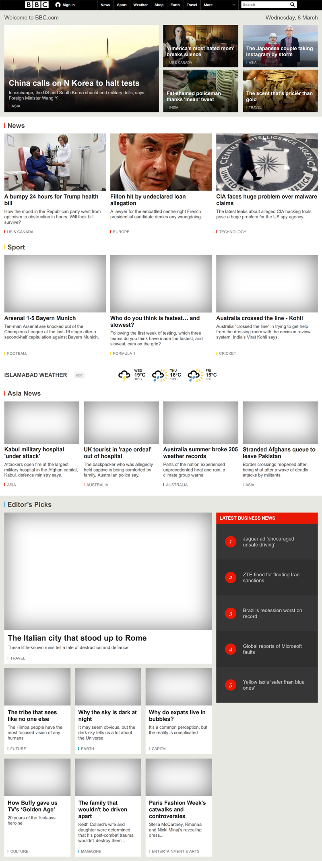

When carefully observer this layout, one can easily identify that this design consist of several nested DIVs. Some of the DIVs are highlighted below.

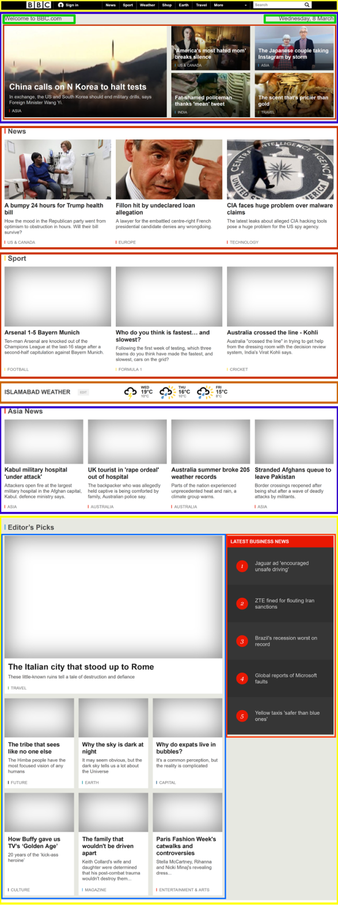

**Your Task:**

Design a web page which has similar layout as shown in the above screenshots. Your layout must be based on DIVs (no tables). You are encouraged to use either internal CSS (using <style> tag) or external CSS (creating a file with .css extension and linking it in the <head> section using <link> tag). An example CSS file is uploaded along with this assignment. You are also encouraged to use different HTML tags we learned so far.

**Hints**

1. Feel free to browse BBC’s website and look into its page source to see how the layout is designed.
2. You can change the color scheme as per your choice.
3. BBC’s website has a menu (More). You can skip them in your layout.
4. Add a Pseudo class to search box and focus it with something of your wish.
5. You are encouraged to use most of the HTML tags you have learned so far or even new tags, which you can learn from W3Schools. (Use of divs & Pseudo Classes is compulsory)
6. Make good use of HTML colors, fonts, font-family, font-sizes and other styles for the ***look and feel*** of the web page.
7. Make sure to test your website with different resolutions by changing the resolution of your screen.
8. High resolution images of both screenshots shown above are also uploaded (see lab3-modified.png and lab3-original.png)

**Important:** Upload you html and CSS files along with the solution.

|  |
| --- |
| Solution |
| Screenshot of web page  HTML Code |

### Deliverables

Compile a single word document by filling in the solution part , Description and submit this Word file on LMS. You must include your name, ID, and class on first page. The lab grading policy is as follows: The lab is graded between 0 to 10 marks. For some of the labs, students have to present their solutions in a viva session. In case of any problems with submissions on LMS, you should contact your lab engineer Mr. Qasim Ali Khan by email at [qasim.khan@seecs.edu.pk](mailto:qasim.khan@seecs.edu.pk).